**OneLegacy’s 2023 National Minority**

**Donor Awareness Month Toolkit**

Dear Donation Community partner,

Thank you for helping us promote the importance of organ, eye and tissue donation with your audience!

This toolkit will provide you with key information and templates to use in August during National Minority Donor Awareness Month (NMDAM).

In addition to this document, you will also find our OneLegacy logo and proposed graphics for you to use on social media channels, e-newsletters and other publications.

**The NMDAM Toolkit includes the following documents:**

Page 2 Facts about Organ, Eye and Tissue Donation

Page 3 Social Media Posts

Page 4 Newsletter Copy Template

Page 5 Sample Graphics to use during National Minority Donor Awareness Month

Social media graphics will be included with this toolkit for your reference and use.

**Fact Sheet – Organ, Eye and Tissue Donation**

* National Minority Donor Awareness Month is an initiative to save and improve the quality of life of diverse communities, by creating a positive culture for organ, eye and tissue donation.

* Organ transplants can be successful regardless of the ethnicity of the donor and recipient. However, the chance of longer-term survival may be greater if the donor and recipient are closely matched in terms of their shared genetic background. That is why it is important for diverse communities to say “YES” to organ, eye and tissue donation.
* Nationwide there are **more than 100,000 people** who are currently waiting for a lifesaving organ transplant, and hundreds of thousands more whose lives could be healed through eye and tissue transplantation.
* The need for lifesaving transplants is greater among communities of color, with **nearly 60 percent** of those who are currently waiting belonging to multicultural communities.
* ***African Americans*** have the greatest need for lifesaving transplants with **28%**, followed by ***Hispanics*** with **22%**, ***Asian/Pacific Islanders*** with **9%** and **less than 1%** of **American Indian/Alaska Natives** and people of **multiracial descent**.
* In California alone **more than 20,000** are waitingto receive lifesaving hearts, livers, lungs, kidneys and pancreas transplants; but there are simply not enough donors to meet the growing need.
* A single organ donor can save **up to eight lives** and improve the lives of **as** **many as 75 more** by donating their corneas and tissue.
* In 2022, organ donation from deceased donors in the United States set an all-time record. More than **21,000 donors** provided one or more organs to save and enhance the lives of others.
* Nearly **43,000 life-saving transplants** were performed in the U.S. in 2022, nearly a 5 percent increase from the number of transplants in 2021.

**Social Media**

# **National Minority Donor Awareness Month – Social Media**

Thank you for supporting National Minority Donor Awareness Month on your social media channels. Your support helps to ensure that accurate information and life-saving encouragements to register as an organ, eye and tissue donor continue to reach the community.

# **Hashtags**

# #MinorityDonorAwareness #OneLegacyNMDAM

Utilizing these hashtags will help our community see your organization’s support. Social media users who view your posts will also be able to connect to other National Minority Donor Awareness Month posts from across the region, state, and country! Those engaging with your posts will be able to see how your organization is honoring a life-saving cause with broad community support. These hashtags lend legitimacy and a sense of community to your National Minority Donor Awareness Month social media posts.

# **OneLegacy**

We are the federally designated, non-profit organ, eye and tissue recovery agency that serves your community. Tagging OneLegacy in your social media posts helps connect your community members to the organization that will ultimately honor the gifts of life they choose to leave if they register as an organ, eye or tissue donor.

Don’t forget to tag us so we can share your post to our stories and further honor those who choose to give the gift of life.

|  |  |
| --- | --- |
| [A picture containing text, clipart  Description automatically generated](https://www.facebook.com/OneLegacy/) | [@OneLegacy](https://www.facebook.com/OneLegacy) |
| [Icon  Description automatically generated](https://www.instagram.com/onelegacyinspires/) | [@OneLegacyInspires](https://www.instagram.com/onelegacyinspires/) |
| [Logo, icon  Description automatically generated](https://twitter.com/OneLegacyNews) | [@OneLegacyNews](https://twitter.com/onelegacynews) |
| [Logo  Description automatically generated](https://www.youtube.com/channel/UC5XfytRxRJdSP-MfPxdPxaA) | [OneLegacy Inspires](https://www.youtube.com/channel/UC5XfytRxRJdSP-MfPxdPxaA) |

**Social Media Posts**

Below you will find some proposed posts and captions to be used during National Minority Donor Awareness Month.

* August is National Minority Donor Awareness Month. Register to become a donor and help save and heal lives. #MinorityDonorAwareness #OneLegacy #[hospital/organization name] [www.OneLegacy.org/Register](http://www.OneLegacy.org/Register)
* Organ transplants can be successful regardless of the ethnicity of the donor and recipient. However, there is a higher rate of long-term survival if the donor and recipient are closely matched in terms of their shared genetic background.

Register as a donor and save lives today! Visit [www.OneLegacy.org/Register](http://www.OneLegacy.org/Register) for more information #MinorityDonorAwareness #OneLegacy #[hospital/organization name]

* A single #organdonor can save the lives of up to eight people and heal 75 more. Save lives today! Register at [www.OneLegacy.org/Register](http://www.OneLegacy.org/Register) #[hospital/organization name] #MinorityDonorAwareness #OneLegacy
* Did you know that more than 60 % of the 100,000+ people currently waiting for a lifesaving transplant belong to multicultural communities? #MinorityDonorAwareness #OneLegacy #[hospital/org name]
* In California there are more than 20,000 people currently waiting for a lifesaving organ transplant. Say “YES” to organ donation and save lives. Visit [www.OneLegacy.org/Register](http://www.OneLegacy.org/Register) to learn more. #[hospital/org name] #MinorityDonorAwareness #OneLegacy
* African Americans have the greatest need for a lifesaving organ transplant, lifesaving organ transplants, followed by Hispanics, Asian/Pacific Islanders and American Indian/Alaska Natives. You can help save lives by saying “YES” to organ, eye and tissue donation! Visit [www.OneLegacy.org/Register](http://www.OneLegacy.org/Register) to register today. #[hospital/org name] #MinorityDonorAwareness #OneLegacy
* Becoming an organ or tissue donor is easy and you can help save someone in need. Register at your local DMV or online at [www.OneLegacy.org/Register](http://www.OneLegacy.org/Register) #[hospital/org name] #MinorityDonorAwareness #OneLegacy

**Newsletter Copy**

August is National Minority Donor Awareness Month and in partnership with OneLegacy, **[Hospital Name]** is joining efforts to inspire multicultural communities to Donate Life and say “YES” to the gift of organ, eye and tissue donation.

Nationwide there are **more than 100,000 people** who are currently waiting for an organ transplant. The need for lifesaving transplants is greater among communities of color, with **nearly 60 percent** of those who are currently waiting belonging to multicultural communities.

Did you know that ***African Americans*** have the greatest need for lifesaving transplants making up **28%** of the current waiting list, followed by ***Hispanics*** with **22%**, ***Asian/Pacific Islanders*** with **9%** and **less than 1%** of **American Indian/Alaska Natives** and people of **multiracial descent**?

You can make a difference TODAY by registering as an organ, eye and tissue donor to help save lives! Visit [www.onelegacy.org](http://www.onelegacy.org) for more information.

[Consider including one of the graphics provided]

**Contact Us**

**ONELEGACY PUBLIC EDUCATION DEPARTMENT**

If you wish to receive media and social media support during

National Minority Donor Awareness Month events at your hospital,

please contact:

[mediarelations@onelegacy.org](mailto:mediarelations@onelegacy.org)

**Social Media Graphics**

Below you will find a sample of our 2023 National Minority Donor Awareness Month Social Media Graphics. These graphics are included in our toolkit folder for your reference.

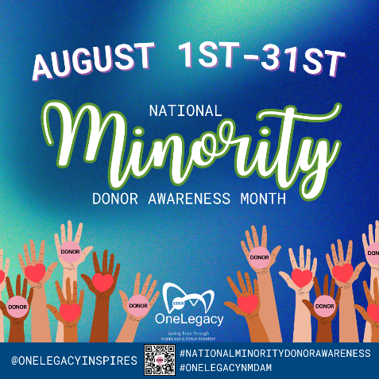 National Minority Donor Awareness Month Graphics with facts about donation

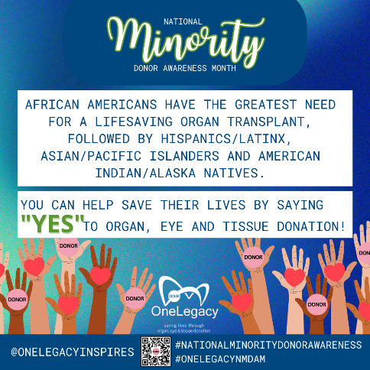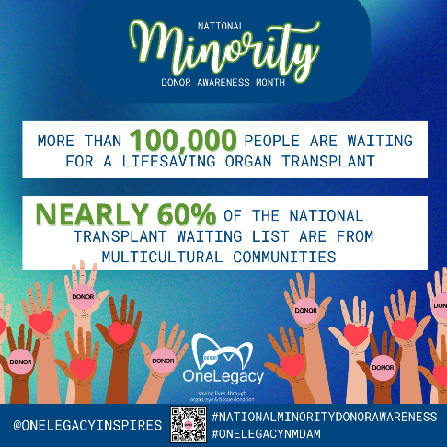

Personal Testimonial Graphics



